Status Screen Information Display – P552 Raptor Only - CGEA1.3

Functional Description

The purpose of the Raptor Status screen display is to provide the status of some of the performance related settings chosen by the driver.
The Raptor Status Screen consists of the following feature statuses:
- Terrain Mode
- Steering Feel
- Advancetrac
- Variable Suspension
- eLocker
- Transfer Case (4x4 modes)

The Raptor status screen shall be accessed via the 5-way Message center display switch.

The Raptor Status Screen warning correlate the 5-way switch and the Operational_Mode to determine when to display the Status screen information.

Interfaces

Interface Context Diagram (I/O Block Diagram)
Figure 1 Warning – Raptor Status Screen Diagram

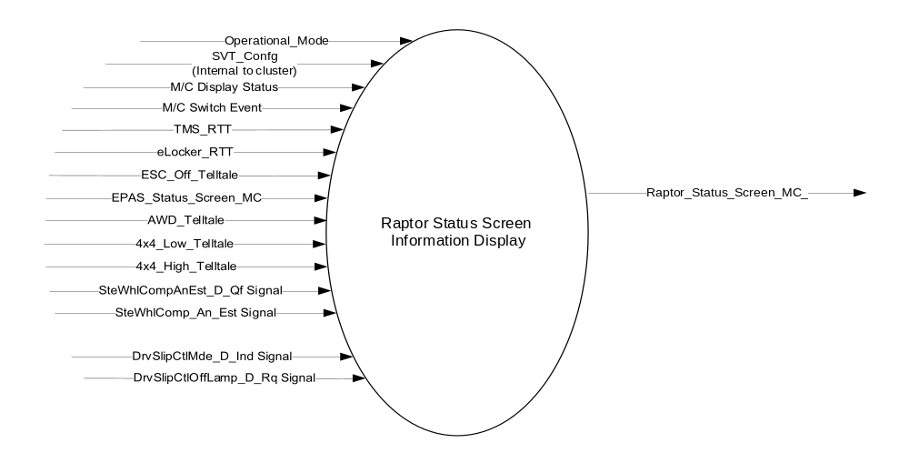

Inputs
      - INTERNAL:
    - Operational_Mode
    - SVT_Confg – Supplier internal config bit that differentiates the SVT cluster from other cluster variants.
    - TMS_RTT – Refer to the Terrain Management System Control Function – CGEA1.3 - P552 Phantom Specific STSS for more information
    - EPAS_Status_Screen_MC – Refer to the “EPAS Selectable Steering Effort Control Function – S550 Specific – CGEA1.3” STSS for more information.
    - 4x4_Low_Telltale –
    - 4x4_High_Telltale –
    - AWD_Telltale –
    - eLocker_RTT –
    - M/C Switch Event – OK Button Press
    - ESC_Off_Telltale – Refer to the “ESC Off Tellate – CGEA1.3” STSS for more information.

      - MUX message on the CAN Bus

- DrvSlipCtlMde_D_Ind Signal
Signal Name | Size  (bits) | Detail | Units | Res. | Offset | State Encoded | Min. | Max.
DrvSlipCtlMde_D_Ind | 2 |  | SED | 1 | 0 |  | 0  (0x0) | 3  (0x3)
 |  | Default_Mode |  |  |  | 0x0
 |  | App_Specific_Off_Mode1 |  |  |  | 0x1
 |  | App_Specific_Off_Mode2 |  |  |  | 0x2
 |  | App_Specific_Off_Mode3 |  |  |  | 0x3

- SteWhlComp_An_Est Signal
Signal Name | Size  (bits) | Detail | Units | Res | Offset | State Encoded | Min. | Max.
SteWhlComp_An_Est | 15 |  | Deg | 0.1 | -1600 |  | -1600 (0x0) | 1676.7  (0x7FFF)

- SteWhlCompAnEst_D_Qf Signal
Signal Name | Size  (bits) | Detail | Units | Res | Offset | State  Encoded | Min. | Max.
SteWhlCompAnEst_D_Qf | 2 |  | SED | 1 | 0 |  | 0 (0x0) | 3 (0x3)
 |  | Fault |  |  |  | 0x0
 |  | No_Data_ Exists |  |  |  | 0x1
 |  | Not_Within_ Specification |  |  |  | 0x2
 |  | OK |  |  |  | 0x3

- DrvSlipCtlOffLamp_D_Rq Signal
Signal Name | Size  (bits) | Detail | Units | Res | Offset | State  Encoded | Min. | Max.
DrvSlipCtlOffLamp_D_Rq | 2 |  | SED | 1 | 0 |  | 0 (0x0) | 3 (0x3)
 |  | Off |  |  |  | 0x0
 |  | On |  |  |  | 0x1
 |  | Slow Flash |  |  |  | 0x2
 |  | Fast Flash |  |  |  | 0x3

Output
- Raptor_Status_Screen_MC – Status screen display.

Function/Performance

Operational Modes

Mode | Differentiating Vehicle Conditions
Sleep Mode | Raptor Status Screen Information Display Inactive
Limited Mode | Raptor Status Screen Information Display Inactive
Normal Mode | Raptor Status Screen Information Display Inactive / Active
Crank Mode | Raptor Status Screen Information Display Inactive / Active

The above table references the setting of the Warning flag as per this section. However, the actual warning display operational modes are displayed in the Message Center section of this SPSS.

Voltage Levels

Refer to the Cluster Features Table located in the Operational Modes and Voltage Range Strategies Section of this SPSS.

Human-Machine Interface

Visual

Indicator Graphics / Display Format
Example graphic:
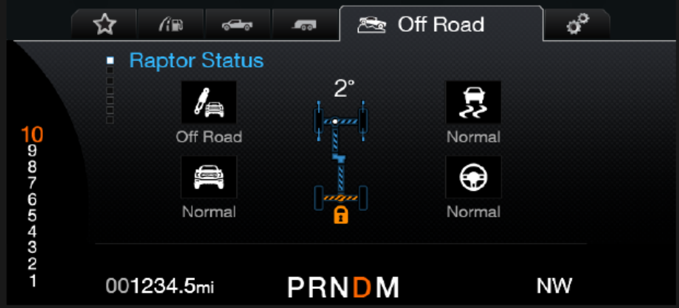
Please refer to program specific graphics library or wallpaper for accurate and latest graphics.

1.3.3.1.2 Indicator Color Coordinates

Reference section COLOR & ILLUMINATION REQUIREMENTS (GRAPHICS).

Audio

None

Switch Control Logic

None.

System Accuracy

Within 100 msec of receiving a message that results in a change of state the cluster will update the output flag to the proper state.

Operation: Performance and Functional

Subsystem Algorithm Flowchart / State Diagram

Figure 2: Raptor Status Screen and RTT Process Flowchart
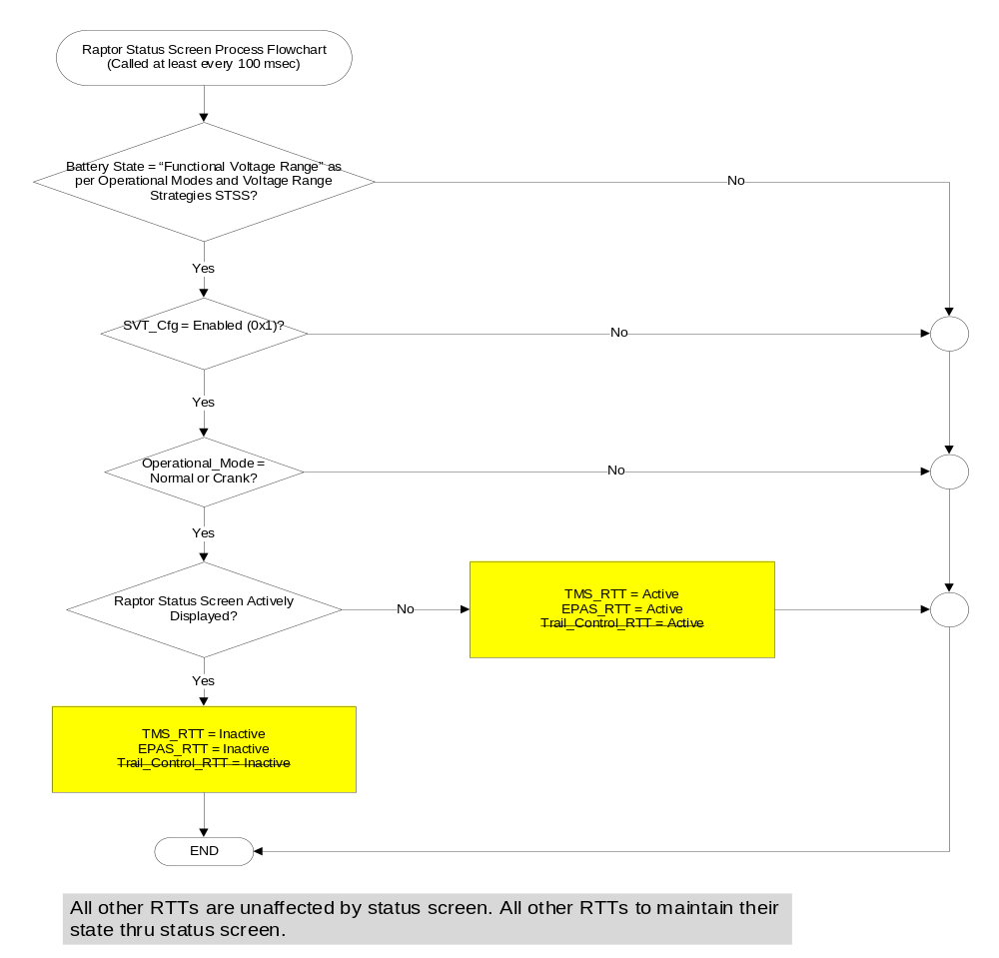
- Driveline and Transfer Case
Operational Mode | 4x4_low_ telltale | 4x4_high_ telltale | AWD_telltale | Driveline_ Graphic
Normal or Crank | Off | Off | Off | 3
Normal or Crank | ON | Off | Off | 2
Normal or Crank | Off | ON | Off | 1
Normal or Crank | Off | Off | ON | 1
Normal or Crank | ON | ON | Off | No change (error condition or proveout)
Normal or Crank | Off | ON | ON | No change (error condition or proveout)
Normal or Crank | ON | Off | ON | No change (error condition or proveout)
Normal or Crank | ON | ON | ON | No change (error condition or proveout)

- Animation
Driveline_ Graphic | Veh_V_ ActlEng | Veh_V_ ActlEng_D_Qf | Driveline_ Animation
X | X | Faulty (0x0),  No Data Exists (0x1), or  Not within  specifications (0x2) | Off
1 or 2 |  | OK (0x3) | Animation 1 ON
3 | > 0.5 kmh | OK (0x3) | Animation 2 ON
X | <= 0.5 kmh or  missing per 1.4.1 | X | Off

- Driveline / Transfer Case Graphic Output
Driveline_Graphic = 1  Blue front and rear,  Green transfer case | Driveline_Graphic = 2  Blue front and rear,  Purple transfer case | Driveline_Graphic = 3  White front, blue rear,  white transfer case
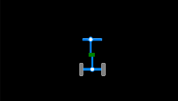 | 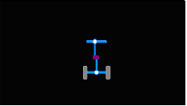 | 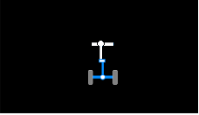  There shall be no blue outline around front

Animation 1 & 2
Animation 1  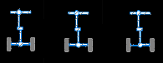 | Animation 2  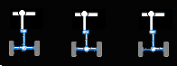
- Animation shall play at a rate of 3.3 frames per second +/- 20%.
- Animation 1 shall animate front and rear drivelines.
- Animation 2 shall animate rear driveline only.
- The transfer case shall be the top layer such that the animation does not appear to go over it; only the driveline(s) shall appear animated.

- Steering angle
Operational Mode |  | Steering_Angle  _Data_Fault |  | Steering_Gear_Ratio_Cfg |  | StWhlComp_An_Est |  | Steering_Angle_Graphic | Steering_Angle_Number
Normal or Crank | False |  | 17:1 |  | 0x0 - 0x209E  (less than -45 deg) |  | -45 deg |  |  | 45°
Normal or Crank |  |  |  |  | >= 0x5C62  (greater than or equal to +45 deg) |  | 45 deg |  |  | 45°
Normal or Crank |  |  |  |  | 0x3DD7 – 0x3F29  (0 deg) |  | 0 deg |  |  | 0°
Normal or Crank |  |  |  |  | 0x209F – 3DD6 and 0x3F2A – 0x5C61  (normal range) |  | Wheel angle as per trunc[(hex2dec(StWhlComp_An_Est)  *0.1 – 1600) / 17.0] |  |  | Abs{ trunc[(hex2dec(StWhlComp_An_Est)  *0.1 – 1600) / 17.0]}
Normal or Crank |  |  | 20:1 |  | 0x0 - 0x1B58  (less than or equal to -45 deg) |  | -45 deg |  |  | 45°
Normal or Crank |  |  |  |  | >= 0x61A8  (greater than or equal to +45 deg) |  | 45 deg |  |  | 45°
Normal or Crank |  |  |  |  | 0x3DB9 – 0x3F47  (0 deg) |  | 0 deg |  |  | 0°
Normal or Crank |  |  |  |  | 0x1B59 – 0x3DB8 and 0x3F48 – 0x61A7  (normal range) |  | Wheel angle as per  trunc[(hex2dec(StWhlComp_An_Est)  *0.1 – 1600) / 20.0] |  |  | Abs{  trunc[(hex2dec(StWhlComp_An_Est)  *0.1 – 1600) / 20.0]}
Normal or Crank | True |  | X |  | X |  | Fault |  |  | Blank
Normal or Crank | X |  | X |  | Missing per 1.4.1 or Never Received |  | Fault |  |  | Blank
Note: If vehicle Steering Gear Ratio is not 17:1 or 20:1 then a new steering gear ratio may need to be added to the
configuration and the StWhlComp _An_Est values will need to be recalculated for the new Steering Gear Ratio. Small
deviations in Steering Gear Ratio value from those above may be acceptable – error analysis needed to deem acceptable

- Steering_Angle_Data_Fault
SteWhlCompAnEst _D_Qf | Steering_Angle_Data_Fault
Not_Within_Specification (0x2)  or  OK (0x3) | False
Fault (0x0) or No_Data_Exists (0x1) for 5 seconds | True
Missing Message Declared per 1.4.1 or Never Recieved | True

- Steering Angle Graphic Output
Steering_Angle_Graphic | Display
-1 to -45 deg  1 degree resolution  When negative, rotate wheels to the right | 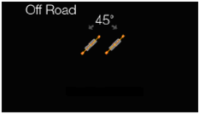
1 to 45 deg  1 degree resolution  When Positive, rotate wheels to the left | 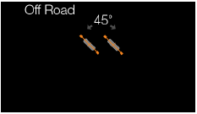
0 deg  Orange lines extend through rear wheels | 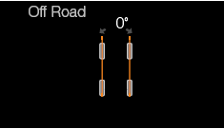
Fault  Position front wheels with 0 rotation, remove orange lines, remove Steering_Angle_Number and grey arrows | 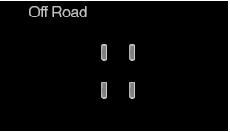
NOTE TO APPLICATION ENGINEER: Typically at key on the SteWhlCompAnEst_D_Qf will initialize to state (0x1) until receiving sufficient data to transition to (0x3). While cluster is receiving (0x1) fault state above with remainder of driveline will be displayed. Transition to (0x3) will generally take driving at above roughly 10 MPH for 100 feet. Contact Brake group applications engineer for details on this initialization process.

- Locker
Operational Mode | Elocker_RTT (from Elocker function) | eLocker_Status
Normal  Or Crank | ON | On
Normal  Or Crank | Off | Off

- Locker Graphic Output
eLocker_Status | Display
Off  (white) | 
ON | 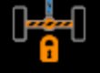

- Variable Suspension Status
Operational Mode | SDM_Cfg | TMS_RTT (from Terrain Management System STSS) | Variable Suspension Status  (example graphic)
Normal  Or Crank | Enabled (0x1) | Normal |   Normal
Normal  Or Crank | Enabled (0x1) | Sport |   Sport
Normal  Or Crank | Enabled (0x1) | Slippery | Normal
Normal  Or Crank | Enabled (0x1) | Deep Snow/Sand |   Off Road
Normal  Or Crank | Enabled (0x1) | Baja | Off Road
Normal  Or Crank | Enabled (0x1) | Rock Crawl | Off Road
Normal  Or Crank | Enabled (0x1) | Tow Haul | Normal

- Terrain Mode Status
Operational Mode | SDM_Cfg | TMS_RTT (from Terrain Management System STSS) | Terrain Mode Status
Normal  Or Crank | Enabled (0x1) | Normal | 
Normal  Or Crank | Enabled (0x1) | Sport | 
Normal  Or Crank | Enabled (0x1) | Slippery | 
Normal  Or Crank | Enabled (0x1) | Deep Snow/Sand | 
Normal  Or Crank | Enabled (0x1) | Baja | 
Normal  Or Crank | Enabled (0x1) | Rock Crawl | 
Normal  Or Crank | Enabled (0x1) | Tow Haul | Tow Haul

Note: Above shown graphics are for example only. Actual graphics to be delivered by the HMI team.
- AdvanceTrac Status Screen States
Operational  _Mode | DrvSlipCtlMde  _D_Ind  Signal | ESC_Off  _Telltale | DrvSlipCtlOff  Lamp_D_Rq  Signal | TMS_RTT | Advancetrac_Status_  Screen_MC  (example graphics)
Normal or Crank | 0x0 | Inactive  (Not Illuminated) | 0x0 | Normal (0x0)  Tow/Haul (0x6) | Normal
 |  |  |  | Slippery (0x2) | Weather
Normal or Crank | 0x0 | Active  (Illuminated) | 0x1 | Deep Snow/Sand (0x3) |  MudSand
 |  |  |  | Baja (0x4) | Baja
Normal or Crank | 0x1 | Active  (Illuminated) | 0x1 | Normal (0x0),  Sport (0x1), Slippery (0x2), Deep Snow/Sand (0x3),  Baja (0x4)  Tow/Haul (0x6) | Traction Off
Normal or Crank | 0x2 | Inactive  (Not Illuminated) | 0x0 | Sport (0x1) | Sport
Normal or Crank | 0x3 | Active  (Illuminated) | 0x1 | Normal (0x0),  Sport (0x1), Slippery (0x2), Deep Snow/Sand (0x3),  Baja (0x4),  Rock Crawl (0x5)  Tow/Haul (0x6) | Off
Normal or Crank | Declared Missing | X | X | X | Off
All Other Cases |  |  |  |  | Inactive

Please refer to the program specific wallpaper for actual graphics.

Figure 3: Raptor Status Screen Layout (example: L2 cluster)

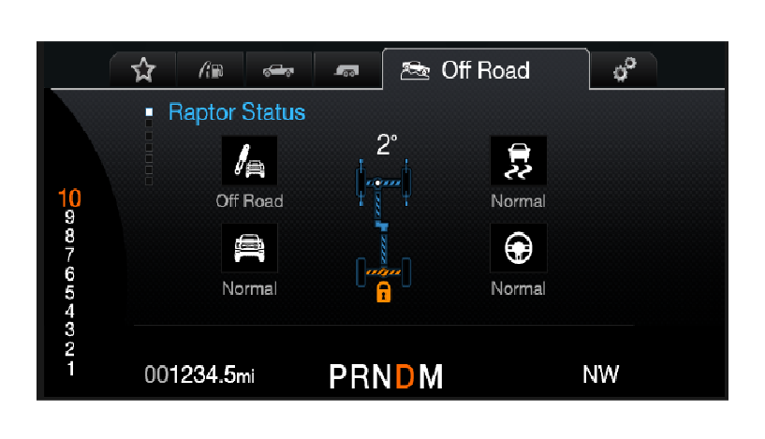

Note: Graphics shown above are for example purposes only. Refer to the program specific wallpaper for

accurate graphics associated with each status.

Figure 3: Raptor Status Screen Layout (example: L1 cluster)

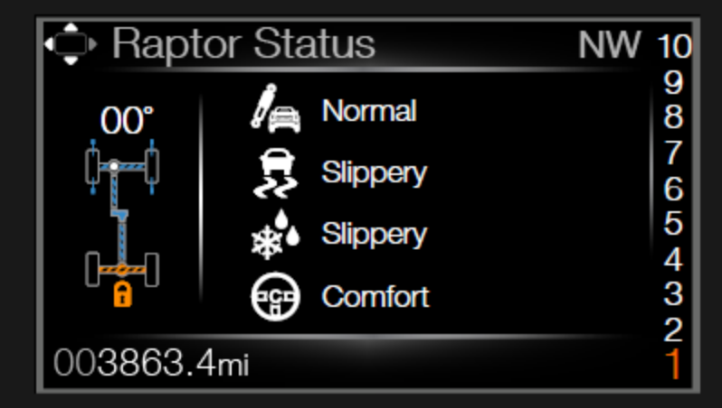

Operation Description (supports algorithm flowchart /state diagram)

- The Raptor Status screen shows the current states of all features it incorporates, as long as the individual feature has been configured as Enabled.

- The Raptor Status screen is an on-demand information display that can be accessed thru the Off Road tab/menu via the 5-way MC switch on the steering wheel.

- The warnings contained within the “Warning – Traction Control OFF_Traction Control ON_Advancetrac OFF_Advancetrac ON – CGEA1.3” STSS shall be displayed regardless of the status screen (even when the Status screen is actively displayed).

Function Safety Classification (EMC)

Class B

Memory Storage
Parameter Name | Description | Value at  Battery Connect | Value at  Module Wake-up
Raptor_Status_Screen_MC | Output that displays status of defined features | Inactive | Do Not Init
EPAS_Status_Screen_MC | Internal Input. Refer to the “EPAS Selectable Steering Effort Control Function – S550 Specific – CGEA1.3” STSS for more information.
ESC_Off_Telltale | Internal Input. Refer to the “ESC_Off_Telltale – CGEA1.3” STSS for more info.
Advancetrac_Status_Screen_MC | Status showing current advancetrac mode to be displayed on the status screen | Inactive | Do Not Init
TMS_RTT | Internal input. Refer to the “Terrain Management System Control Function – CGEA1.3 - P552 Phantom Specific” STSS for more information
eLocker_RTT | Internal Input. Refer to the “eLocker RTT – CGEA1.3” STSS for more info.
DrvSlipCtlMde_D_Ind Signal | Input signal received by the cluster | Default_mode (0x0) | Default_mode (0x0)
SteWhlComp_An_Est Signal | Input signal received by the cluster | 0 degrees | 0 degrees
TrailCtl_D_Stat Signal | Input signal received by the cluster | Off (0x0) | Off (0x0)
DrvSlipCtlOffLamp_D_Rq | Input signal received by the cluster | Off (0x0) | Off (0x0)
Operational_Mode | 4 state indicator for cluster operational mode | Limited | Limited or Normal or Crank

Prove Out

No.

Reconfigurable Telltale

No.

Message Center Msg

Information message IDs as defined in the Global Text Message List.
.

Error Handling

None

Diagnostics

Self Test

None

Engineering Test Mode

Not Applicable

Part II Performance

Supported Diagnostic Trouble Codes (DTCs)

DTC | Description | When Logged
None

Reference Specification

IS-0052 OPERATING VOLTAGES - FUNCTIONAL/PERFORMANCE
IS-0069 FUNCTIONAL IMPORTANCE CLASS
IS-0324 WINDSHIELD & OTHER REFLECTIONS
IS-0327 WARNING INDICATOR EVALUATION
IS-0379 NORTH AMERICAN WARNINGS AND INDICATORS STRATEGY

IL-0019 GENERAL ILLUMINATION DIMMING
IL-0021 CRAFTSMANSHIP – DISPLAYS
IL-0022 GENERAL ILLUMINTATION COLOR
IL-0023 CLARITY/LEGIBILITY/READABILITY/VISUAL CONTRAST
IL -0043 OPERATIONAL ENVIRONMENT FUNCTIONALITY
IL -0045 COLOR
IL -0048 ILLUMINATION ACCEPTABILITY

03-0661 PLACEMENT: CONTROL AND DISPLAY LOCATIONS
03-0662 PLACEMENT: LOGICAL GROUPING FUNCTION AND USAGE
03-0664 PLACEMENT: DOWN VISION TO COMPONENTS WITH HIGH VISUAL DEMAND
03-0665 PLACEMENT: EXPECTED LOCATIONS OF CONTROLS AND DISPLAYS VDS
03-0670 INTERIOR VISIBILITY
03-0671 INTERIOR VISIBILITY: REFLECTIONS FROM COMPONENTS & SURFACES
03-0672 INTERIOR VISIBILITY: REFLECTIONS IN DISPLAYS
03-0673 INTERIOR VISIBILITY: VISUAL OBSCURATIONS
03-0674 INTERIOR VISIBILITY: ILLUMINATION CONTROLS / DISPLAYS
03-0675 INTERIOR VISIBILITY: VEILING GLARE
03-0677 INTERIOR VISIBILITY: SUNLIGHT WASHOUT
03-0681 IDENTIFICATION: CHARACTER AND SYMBOL SIZE
03-0682 IDENTIFICATION: LEGIBILITY
03-0685 IDENTIFICATION: SYMBOLS, ABBREV FOR CONTROL
03-0721 LOGIC OF OPERATION: OPERATIONAL STEREOTYPES
03-0722 LOGIC OF OPERATION: INTERPRETATION
03-0723 LOGIC OF OPERATION: USE OF SYSTEMS WITH VISUAL DISPLAYS

Revision History
SPSS Module Revision History

Revision Level | Name | Change Description | Date
1.0 | V. Patel | Initial revision for 2017 P552 RAPTOR cluster variant.  Feature owners: Tom Wroblewski (Ford Performance Team) | 6/22/2015
1.1 | V. Patel | Update to clarify supplier Q&A, there is no change to feature functionality.  The CAN signal DrvSlipCtlOffLamp_D_Rq was not captured in the inputs section in the STSS. Added reference to this signal and its definition wherever necessary.  An issue was found where the TMS team did not like that 4x4mode and eLocker RTTs were deactivated while Status screen was active.  Section 1.3.5.1, figure 2: Removed the 4x4mode and eLocker RTTS from the flowchart, so they remain unaffected by the Status screen. | 2/12/2016
1.3 | S. Watkins | At the request of Tim Krieg per DI Forum 2/26/2016, we are modifying the AdvanceTrac Status Screen States. (Approved in DI Change Control 3/3/2016)  - Modified Table 1.15 AdvanceTrac Status Screen States (moved Sport and Rock Crawl). Note Sport is now part of a new row with a different graphic. | 3/4/2016
1.4 | V. Patel | Updates required to support changes made on ‘19 MY Raptor features. Biggest change is replacing Hill Descent status with Trail Control status.  Other changes: Adding a Advancetrac status for Tow/Haul mode.  Renaming a couple of terrain modes to match ’19 MY nomenclature.  - Section 1.1: Replaced Hill Descent with Trail Control in the description.  - Section 1.2.1, figure 1: Replaced Hill Descent input with Trail Control CAN signal input (TrailCtl_D_Stat).  - Section 1.3.5.1,  - Figure 2: Replaced Hill Descent RTT with Trail Control RTT so that RTT is not displayed while Status screen is actively displayed.  - Table 1.13: Replaced Hill Descent status matrix with Trail Control status matrix.  - Table 1.14: Changed “Weather” mode to “Slippery” and “Mud/Ruts” with “Deep Sand/Snow” mode. Only the names have changed, other attributes remain the same.  - Table 1.15: Added Tow/Haul mode to the matrix. Changed “Weather” mode to “Slippery” and “Mud/Ruts” with “Deep Sand/Snow” mode.  - Figure 3: Replaced Hill Descent status with Trail Control status in the example status screen graphic.  - Section 1.3.5.4: Replaced Hill Descent CAN input with Trail Control (TrailCtl_D_Stat) CAN input. | 5/30/2017
2.0 | V. Patel | Trail Control status is being replaced by the Variable suspension status in the status screen display.  Direction provided by 2019 P552 Raptor team  DI CC approval: 3/27/2018 (offline)  All changes are highlighted in yellow  Section 1.1: Replaced Trail control with Variable Suspension  Section 1.2.1, Figure 1: Removed TrailCtl_D_Stat as an input from the context diagram since it is not required anymore.  Section 1.2.2: Removed CAN signal detail table for TrailCtl_D_Stat  Section 1.3.5.1, figure 2: Struck out Trail Control RTT from the flowchart since it has been removed from the status screen. Trail control is not affected by the status screen display anymore.  Table 1.12: Replaced the state matrix for Trail Control status with Variable Suspension status. | 3/27/2018
2.1 | V. Patel | This version changes the speed threshold to display 4x4mode animation from 3 mph to 0.5 kmh. This is to ensure that the animation is shown when vehicle is in Trail Control mode, which could be a low speeds. (~ 1kmh).  DI CC approval: 5/3/2018  Feature owner: Ford Performance, Raptor electrical team.  Section 1.3.5.1, table 1.5: Change speed threshold to 0.5 kmh (change highlighted in green) | 5/3/2018

